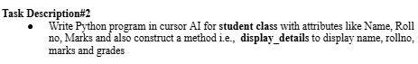

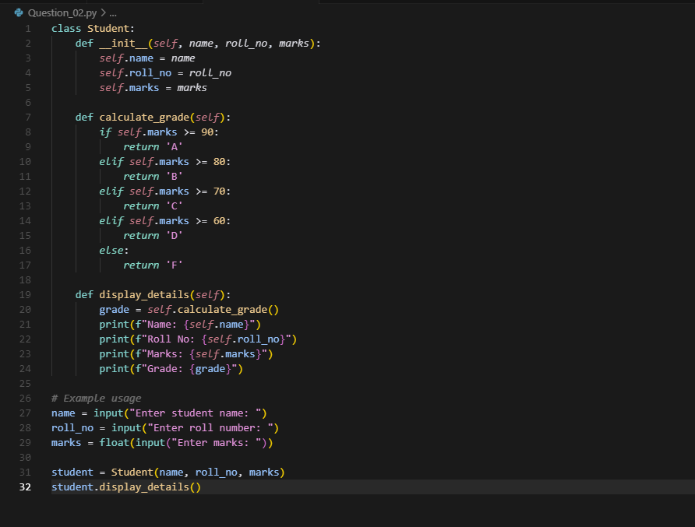

Output :

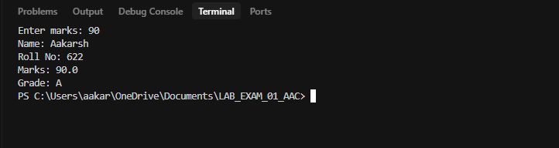

Prompt :

Write a Python program that defines a Student class with attributes for Name, Roll No, and Marks. Include a method called display_details that prints the student's name, roll number, marks, and grade (based on marks).

Explanation :

Student Class Specification
- Attributes (initialized when object is created):
  - name → Student’s name
  - roll_no → Student’s roll number
  - marks → Student’s marks
- Methods:
  - calculate_grade()
    - Determines grade based on marks:
      - 'A' → marks ≥ 90
      - 'B' → marks ≥ 80
      - 'C' → marks ≥ 70
      - 'D' → marks ≥ 60
      - 'F' → marks < 60
  - display_details()
    - Prints:
      - Student’s Name
      - Roll Number
      - Marks
      - Calculated Grade
- Program Usage:
  - Ask user to enter:
    - Name
    - Roll Number
    - Marks
  - Create a Student object using entered details.
  - Call display_details() to show all student information.

